Pastor Tom M. Mose
News letter March 2013

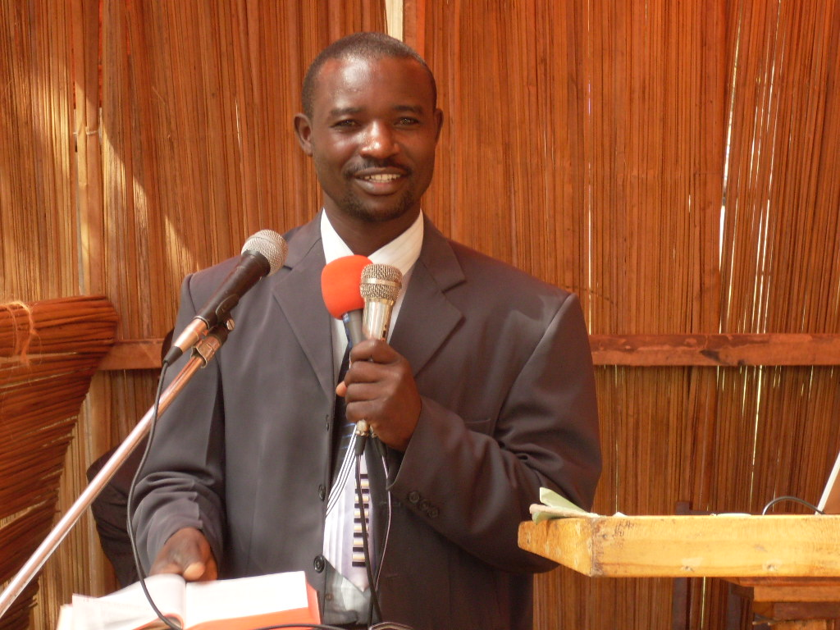

Pastor Tom M Mose

P.O. BOX 3523,
KISII – KENYA
EAST AFRICA.
Email: tmmose@yahoo.com
Phone:+ 254-722-329 129

Warm Christian greetings in the name of Christ our everlasting Lord, who can deliver us out of the hand of Satan; to Him be glory, honor, majesty, power and worship forever and forever, Amen. I praise God for the friendship we enjoy, I am thankful and very blessed to experience a love between and acceptance of two people which is unconditional truly is a blessing for all concerned.
My dear loved one of my Father, time seems to have taken an extra wing to its pair of wings. It is in no time at all that unrest, discord, disorder, chaos and pain is seen in more and more places in our run down old planet. People are concerned at what is happening; not only Christians, but thinking men of all persuasions are alarmed at the course this planet is taking. Common men make the point that if Jesus doesn’t come soon, mankind will utterly destroy this planet, besides the wars that are being waged.
Life looks hopeless for many young and old, especially those trying to make it without Christ.
It is time for the faithful few who remain; to unite encouraging one another and holding up the banner of truth high. We may be scorned and denied by the majority who have chosen darkness rather than light, wrong rather than right; but we have a saviour who will redeem us and a heavenly Father who watches over us.

Many a time we are burdened with the deepening crisis of an apostasy, worldliness and sin within the members of God’s Church. It seems to us that nothing is considered sacred any more. The Holy Commission that God had given, making the Seventh-day Adventist Church his depositary of His Holy truths for these last days, seems to be fading away alarmingly. The encroachment of worldly goals, practices and ambitions, were evident in the alarming invasion made into the Seventh-day Adventist Church by the entertainment media of the world and by the ecumenical movement which caused a drifting away from the special purposes that God has entrusted to His Church. 1st Peter 2:9

I believe that the Seventh-day Adventist Church was called out by God to be a special people with a special message and a special mission and ultimately a special destiny. The Seventh-day Adventist Church is the only Church to take the everlasting gospel contained in the three angel’s messages to the world. No other Church of Christendom knows, believes or lives this message and therefore cannot share this message. I have seen that Satan has made the Seventh-day Adventist Church the object of his malicious and horrendous attacks, just as prophesied in Revelation 12:17.

Yes l agree that there are honest and sincere men and women in all other faiths, but they do not share with us the everlasting gospel. I pray that many of these dear people will one day soon be among those who will respond to the call. (Come out of her My people. Rev. 18:4).
The Seventh-day Adventist is the Church I love and have served from my teenage years up to now.
It is this Church that molded me. Before l was a Roman Catholic and kept Sunday as the day of the Lord. Then God showed me the Sabbath, and I took that light to my family because they were a Roman Catholic. By God’s grace, my parents, brothers and sisters have accepted the Sabbath and are strictly Sabbath-keepers and are health reformers, embracing the total vegan diet.
So this church molded my values, my attitudes, my beliefs and my lifestyle as well as my vision. It pursued me, wooed me and eventually won me. At the age of 21 years, following the ministry and example of Jesus, I chose to follow Him all the way and sealed my love for Jesus through baptism.
I have loved the clear testimony that is presented here by the Spirit of Prophecy. I thrilled to the prophetic unfolding of the messages through our evangelist. I loved the certainty of the messages that had been preached. The certainty of the soon return of Jesus, the One who is our High Priest and is willing to stand up for me in the judgment. I rejoice at the certainty of the resurrection of the saints. And most of all I love the certainty of the double portion of God’s blessings that have been promised to God’s faithful Sabbath-keepers.
This is the Church that l have eagerly directed hundreds of people who have responded to my house to house visitation and Bible studies. I have consistently defended it against attacks directed at us; God’s Church.
I am bewildered however as I wonder what has happened to God’s church. I still love God’s church and I will always love it. But the church has changed. It has brought in strange voices, false doctrines and teachings from the pulpits. There is strange music as now we hear beats of drums and the deafening sounds of synthesizers. You can see glittering adornments on the members
So please brother whatever I have done or written about the Church is born of my deep conviction and devotion. Now it has pastors who preach a tame message week after week, to their spiritual needy and truth thirsty congregations. These pastors gave their seemingly important messages in the deceptive cloak of the Charismatic influence.
I love God’s church and I will not be less consistent. It is loyalty to Jesus and our historical Bible based doctrinal beliefs that motivate my service to the Church. I plead that you accept my sacrificial service as being unto God and to his kingdom. I entreat you to understand that it is a burden for perishing souls in this dark corner of the world that constrains me.
I am longingly looking for workers or leaders whose only goal will be to help our people to find the pathway to heaven.
My plea to the leaders of the world field is that you put aside the politics and the infighting which only pleases Satan. Forget the attempts to unify the members upon false principles through coercion, and the man made documents such as the “The twenty-eight, Fundamental Beliefs” or the flawed and uninspired Seventh-day Adventist Church manual or perhaps many of the General Conference actions.
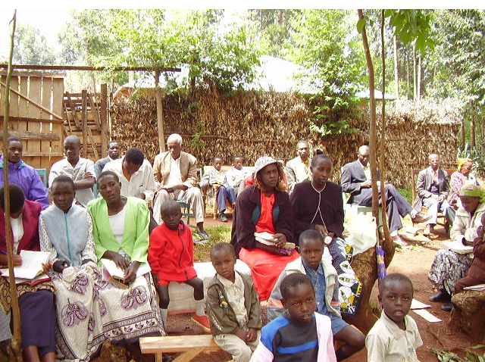

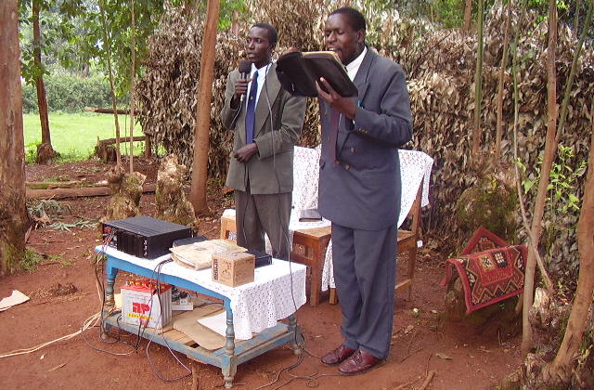

In Jesus Christ, the One who will come soon, clothed with vesture dipped in blood, whose name is the word of God. Rev. 19:13, be love and mercy and peace unto you.
It is written, Malachi 4:5 “Behold, I will send you Elijah the prophet before the coming of the great and dreadful day of the LORD.” In a time of terrible darkness and apostasy in Israel, when Baal worship was the popular order of the day; then God called Elijah to bear a message of warning and of judgment to come.
Brethren our work here in Kenya is growing and people are accepting the message and are interested in learning about the truth. As a people we are to stand firm on the platform of eternal truth that has withstood tests and trials. We are to hold to the sure pillar of our faith the principal of the truth that God has revealed are our only true foundation. God desires to bring earth to a close and He wants people who are prepared to give the final message. He could not use the heathens and He certainly cannot use the papal Church. Neither can he use Protestantism. But He might be able to use Seventh-day Adventists; but only if He could arouse them from this spiritual lethargy. Brethren, the proclamation of the first, the second, and the third angel’s messages have been located by the word of inspiration. “In the future, deception of every kind is to arise, and we want solid ground for our feet. We want solid pillars for the building. Not one pin is to be removed from that which the Lord has established.” Review and Herald, May 25, 1905. What we desperately need now is genuine and thorough repentance over our sins of self righteousness (Laodiceanism). We have seen the main stream churches are now joining together in reversing themselves on their former position of Antinomianism. They urge the nation to keep the Ten Commandments where the fourth commandment is Sunday not the Sabbath of the seventh day.
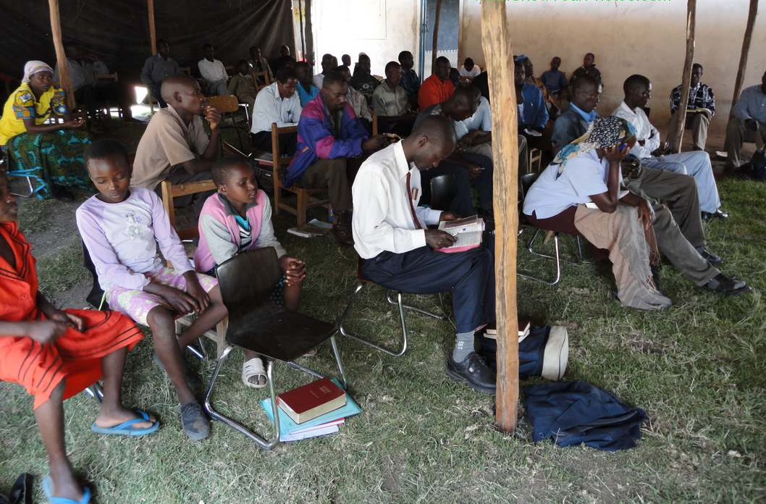

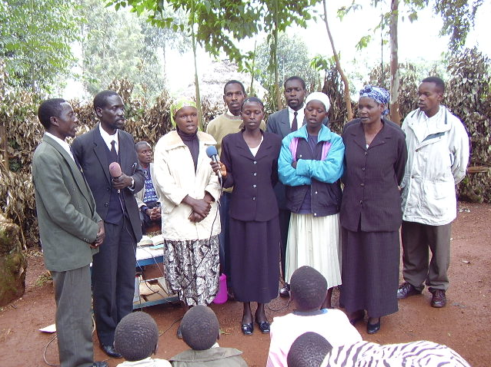

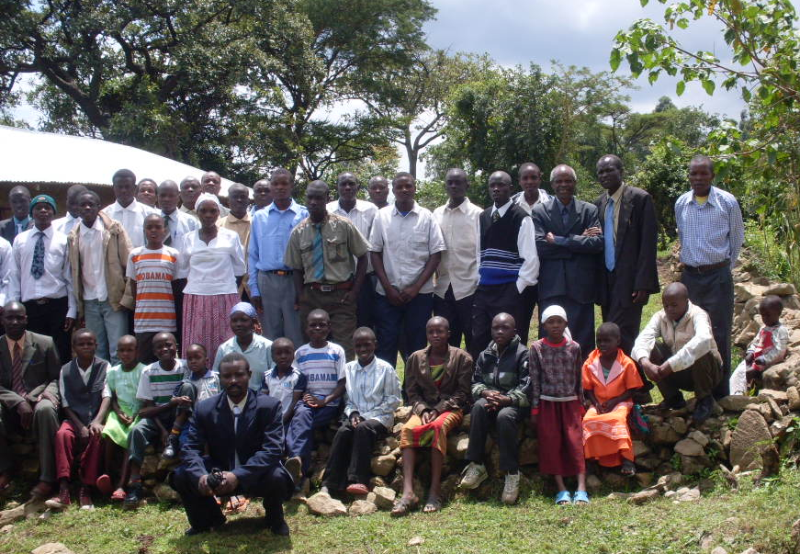
Pastor Tom with Church members.
It was Friday evening and we were opening the Sabbath. We got our loud speaker and started song service and then a sermon opening the Sabbath and we welcomed the clan for the service tomorrow. We were three speakers and a number of youths who were going house to house distributing our literature. We also had adults who were assisting in food preparation. Our program was to have all the morning hours spent in Bible study and then visiting people in their homes, where we then invited them to come to our meeting. And in the afternoon we had public meeting in the open air, from 2.00 o’clock to 5.00 o’clock. Again from 7.15 we had another meeting where we were teaching, now using a slide show with a projector. We had PowerPoint lessons of the sanctuary and prophecy, with latest of world events. After each lesson a call was made, for anyone that may have made a decision to follow Jesus. And in every call two or three could be found who were welcome to the front and we prayed for them and their names were taken so that a follow-up could be arranged. We realized that many people were attending the evening lessons from 7.15 up to 9.00 p.m. People liked these night lessons because they could see the slides on the projector. Others feared attending day time for fear of their leaders, while others were busy at during working hours.
For two weeks we presented this subject clearly.
- Prophecy. The book of Daniel and Revelation was opened to people clearing Daniel chapters 2, 7, 8, 9 and Revelation Chapters 2 and 3 where we covered the church History and Chapter 7 and 8. We spoke about the sealing and then we were able to cover chapters 12, 13, 14, 17 and 18. When chapters 17 and 18 were presented, many people made a decision to come and join the true church, especially when they learned who the Harlot woman riding a beast was and that she was a mother of harlots. That is when they saw that their churches were daughters of Babylon. Then as we moved to 18 and made a call to separate from Babylon many came to the front and this is the day we saw a big number accepting the truth.
- We also taught the Sanctuary message and it helped us when we were explaining the anti-Christ and we showed them the worship service as God directed the children of Israel and our time.
- We had health lessons with a cooking class. We taught people how to cook healthful food and how to treat diseases with natural remedies.

The Sabbath was clearly presented as the seal of God when we were teaching about the Decalogue of the Ten Commandment of God.
Now at the end of the two weeks which was on Sabbath, we had altogether 58 souls who accepted Christ as their personal savior. Out of this number 27 were baptized yesterday; those who had been attending the Bible study with the Bible workers, while the rest are enrolled in Baptismal class to be baptized after they complete the course. Of the 27 members some were SDA’s who had backslidden. We were able to distribute 34 King James Bibles to those who had none, especially those who were baptized; but the demand was big because as we entered into many homes, many people are without Bibles even those who attend their Sunday churches. We had 89 booklets of Secret Terrorists; Desire of Ages 16 copies; 32 Bibles; Ministry of healing 12 copies and National Sunday law books; Steps to Christ 23 copies Kiswahili and English; 8 copies of great controversy and 2600 tracts of “Behold He Cometh, World crisis foretold and future facts.”
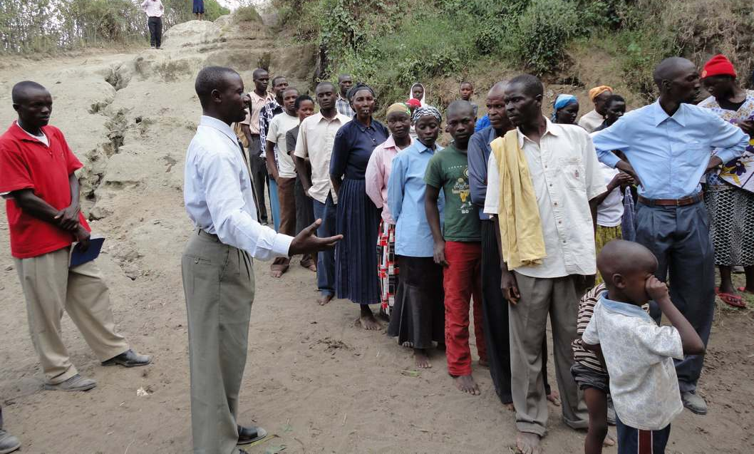

Expenditure: We spent Kshs 35,000 that is equivalent to $443 US, to run this crusade. And also the members contributed food and other things.
We were faced with challenges from Sunday-keeping pastors who were warning their members not to come to our meeting and came around to see who was coming. And they warned their members not to invite us to their homes nor hold any Bible discussion with us. But God worked this out when we opened the lesson of health. Many people came because their health was troubling them and through this we got them and even others came who wanted to be taught how to prepare food.
In addition to the other problems, the SDA conference pastors were attacking us as they also warned members not to come to our meetings. The elders and pastors were constantly around to see who was coming to our meeting. So people feared to be put out of the church and therefore could not come boldly. Other Pentecostal churches started their meetings at the same place, which was meant to counter our meetings. We were also disturbed with rain and we lost three lessons due to the inclement weather as we had no shelter. Other times it was early or late.
We are serving a wonderful God. He provided us with security and he was on our side. We ended up our meeting well on Sabbath with blessings.
Our request:
We are appealing to our Brethren to awake and help us with materials. We need books and tracts for distribution.
God has helped us in that we have translated the book “Patriarchs and Prophets” into a Kiswahili language, which the majority could read as this language is spoken in 6 different countries: Kenya, Uganda, Tanzania, Rwanda, Burundi, and Congo. With these books we will reach many souls. So this book is ready, but we are unable to print. Is there any way you can help us to print? We had previously done “Early Writings” and “Christ Object Lessons” into Kiswahili and we printed 1500 copies each.
It is our sincere prayer that there may be a way that you will help with this work.

May God bless you for your support and moral encouragement.

In the love of Christ our Savior and soon coming King,

On behalf of our brothers and sisters in the Kenyan Victory Everlasting Gospel Free Seventh-day Adventist Churches.

